**Sunday:**

Full Body

**Warm-Up (15 minutes):**

- 5 minutes of light cardio (jogging, cycling, or elliptical)

- Dynamic stretches (arm circles, leg swings, hip circles, etc.) focusing on all major muscle groups 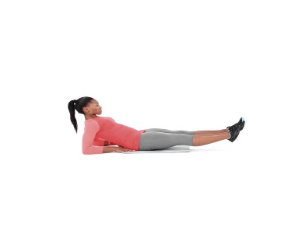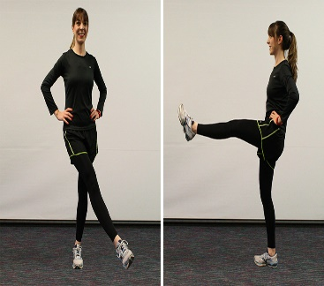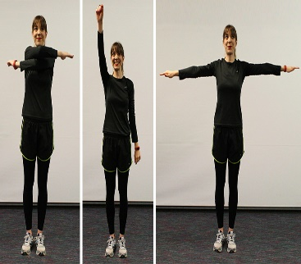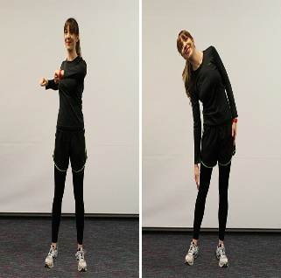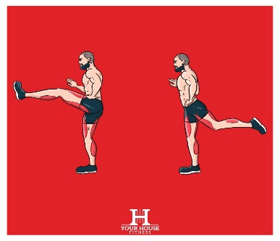

- 5 minutes of mobility drills (foam rolling, lacrosse ball rolling, or dynamic movements to improve joint mobility)

**Strength Training (45 minutes):**

- Barbell Squats: 4 sets x 8-10 reps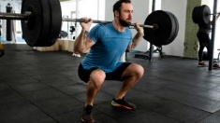

- Deadlifts: 4 sets x 6-8 reps

- Bench Press: 4 sets x 8-10 reps

- Pull-Ups or Lat Pulldowns: 4 sets x 8-10 reps

- Barbell Rows: 4 sets x 8-10 reps

- Overhead Shoulder Press: 3 sets x 8-10 reps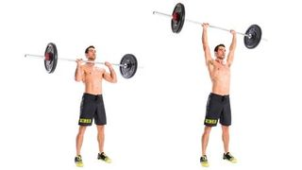

**Muscle Building (30 minutes):**

- Dumbbell Lunges: 3 sets x 10-12 reps per leg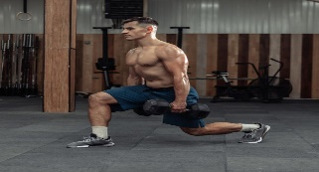

- Dumbbell Romanian Deadlifts: 3 sets x 10-12 reps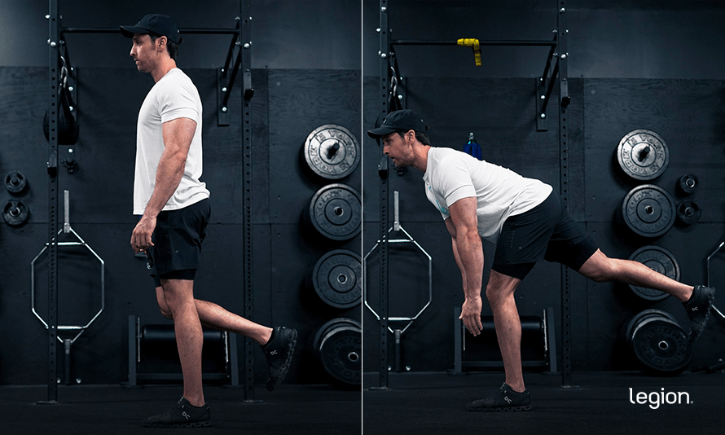

- Dumbbell Chest Flyes: 3 sets x 10-12 reps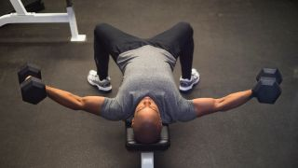

- Dumbbell Bicep Curls: 3 sets x 10-12 reps

- Tricep Dips: 3 sets x 10-12 reps

- Cable Crunches: 3 sets x 12-15 reps

**-**Standing Calf Raises

* Focus: Gastrocnemius development
* Sets: 4
* Reps: 12-15
* Rest: 60-90 seconds
* Load: Moderate to heavy (use dumbbells or a barbell)

**-** Seated Calf Raises

* Focus: Soleus development
* Sets: 4
* Reps: 12-15
* Rest: 60-90 seconds
* Load: Moderate to heavy (with a calf raise machine or weights on knees)

**Endurance and Speed Training (30 minutes):**

- HIIT (High-Intensity Interval Training) on Treadmill:

- 5-minute warm-up at a moderate pace

- 30 seconds sprinting at maximum effort

- 60 seconds walking or light jogging (active recovery)

- Repeat the sprint/walk cycle for 10-15 minutes

- Uphill Running: 3 sets x 2-minute sprints at a challenging incline, followed by 1 minute of rest between sets

- Plyometric Exercises:

- Box Jumps: 3 sets x 10 reps

- Jump Squats: 3 sets x 12 reps

- Burpees: 3 sets x 10 reps

**Cool Down and Stretching (10 minutes):**

- 5 minutes of light cardio (walking or cycling)

- Static stretches targeting all major muscle groups (hold each stretch for 20-30 seconds)

- Foam rolling or self-massage to release tension in muscles

**Monday:**

Back

### Warm-Up

Begin with a dynamic warm-up to prepare your back muscles and surrounding areas for intense activity. This should take 10-15 minutes.

- **Arm Circles**: 2 sets of 30 seconds (forward and backward) 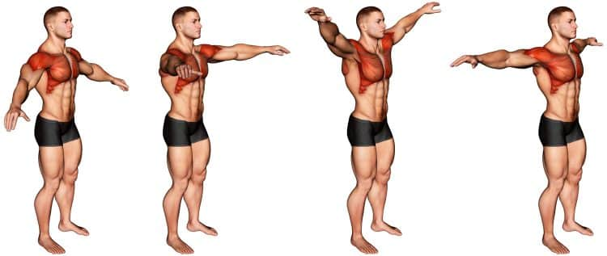

- **Shoulder Dislocations**: 2 sets of 10 reps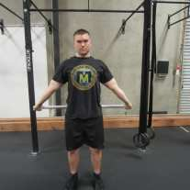

- **Cat-Cow Stretches**: 2 sets of 10 reps

- **Scapular Push-Ups**: 2 sets of 10 reps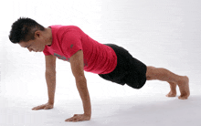

### Workout

**1. Pull-Ups**

- Focus: Lat strength and endurance

- Sets: 4

- Reps: AMRAP (as many reps as possible)

- Rest: 2-3 minutes

- Note: If you can do more than 15 reps consistently, add weight with a belt or vest.

**2. Barbell Deadlifts**

- Focus: Overall back strength and explosiveness

- Sets: 4

- Reps: 6-8

- Rest: 2-3 minutes

- Load: Heavy (aim for 80-85% of your 1RM)

**3. Bent-Over Barbell Rows**;p-

- Focus: Middle back strength and muscle mass

- Sets: 4

- Reps: 8-10

- Rest: 2 minutes

- Load: Moderate to heavy

**4. Dumbbell Single-Arm Rows**

- Focus: Unilateral strength and muscle development

- Sets: 3

- Reps: 10-12 per side

- Rest: 90 seconds

- Load: Moderate

**5. T-Bar Rows**

- Focus: Middle back strength and development

- Sets: 3

- Reps: 10-12

- Rest: 90 seconds

- Load: Moderate to heavy

**6. Face Pulls**

- Focus: Upper back and rear delts

- Sets: 3

- Reps: 12-15

- Rest: 60-90 seconds

- Load: Moderate

**7. Explosive High Pulls**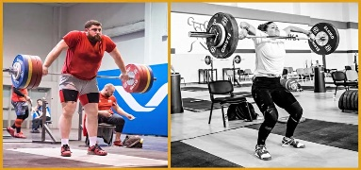

- Focus: Explosiveness and traps

- Sets: 3

- Reps: 8-10

- Rest: 90 seconds

- Load: Moderate

- Note: Use a barbell and perform a dynamic pull from the ground to shoulder height.

**8. Barbell Shrugs**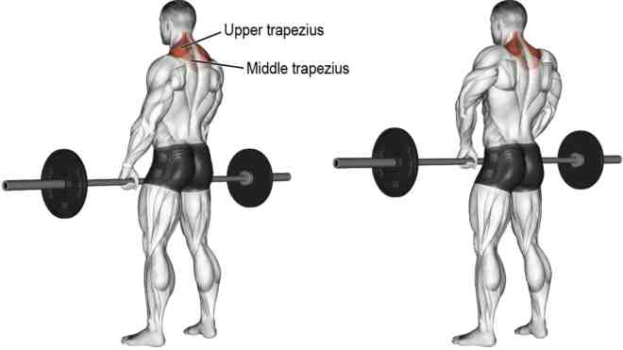

* Focus: Upper traps
* Sets: 4
* Reps: 10-12
* Rest: 90 seconds
* Load: Moderate to heavy

**9. Dumbbell Shrugs**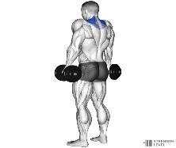

* Focus: Upper traps and traps endurance
* Sets: 4
* Reps: 12-15
* Rest: 90 seconds
* Load: Moderate (ensure good posture)

**Endurance and Speed Training (30 minutes):**

- HIIT (High-Intensity Interval Training) on Treadmill:

- 5-minute warm-up at a moderate pace

- 30 seconds sprinting at maximum effort

- 60 seconds walking or light jogging (active recovery)

- Repeat the sprint/walk cycle for 10-15 minutes

- Uphill Running: 3 sets x 2-minute sprints at a challenging incline, followed by 1 minute of rest between sets

- Plyometric Exercises:

- Box Jumps: 3 sets x 10 reps

- Jump Squats: 3 sets x 12 reps

- Burpees: 3 sets x 10 reps

### Cool Down and Stretching

Finish with a cooldown and stretching to aid recovery and flexibility. This should take about 10-15 minutes.

- **Static Stretching**: Focus on lats, traps, shoulders, and spine.

- **Foam Rolling**: Target the back muscles, particularly the lats and traps.

**Tuesday:**

Upper body

### Warm-Up

Start with a dynamic warm-up to prepare your muscles and joints for the workout. This should take about 10-15 minutes.

- **Arm Circles**: 2 sets of 30 seconds (forward and backward) 

- **Shoulder Dislocations**: 2 sets of 10 reps

- **Jumping Jacks**: 2 sets of 30 seconds

- **Push-Ups**: 2 sets of 10 reps (moderate pace) 

### Workout

**1. Bench Press**

- Focus: Strength and power

- Sets: 5

- Reps: 6-8

- Rest: 2-3 minutes

- Load: Heavy (aim for 80-85% of your 1RM)

**2. Pull-Ups or Chin-Ups**

- Focus: Strength and endurance

- Sets: 4

- Reps: As many as possible (AMRAP)

- Rest: 2 minutes

**3. Dumbbell Shoulder Press**

- Focus: Strength and stability

- Sets: 4

- Reps: 8-10

- Rest: 90 seconds

- Load: Moderate to heavy

**4. Bent-Over Barbell Rows**

- Focus: Strength and muscle endurance

- Sets: 4

- Reps: 10-12

- Rest: 90 seconds

- Load: Moderate to heavy

**5. Explosive Push-Ups**

- Focus: Explosiveness

- Sets: 3

- Reps: 10-12

- Rest: 90 seconds

**6. Cable Face Pulls**

- Focus: Shoulder health and endurance

- Sets: 3

- Reps: 12-15

- Rest: 60 seconds

**7. Biceps Curls**

- Focus: Strength and endurance

- Sets: 3

- Reps: 10-12

- Rest: 60 seconds

- Load: Moderate

**8. Triceps Dips**

- Focus: Strength and endurance

- Sets: 3

- Reps: 10-12

- Rest: 60 seconds

**3. Donkey Calf Raises**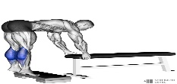

* Focus: Gastrocnemius and soleus
* Sets: 4
* Reps: 12-15
* Rest: 60-90 seconds
* Load: Moderate to heavy (with a weight plate or machine)

**4. Jumping Calf Raises**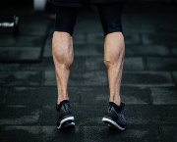

* Focus: Explosiveness and calf endurance
* Sets: 3
* Reps: 15-20
* Rest: 60-90 seconds
* Note: Perform rapid jumps to engage explosiveness.

**5. Plyometric Exercises:**

* + Box Jumps: 3 sets x 10 reps
  + Jump Squats: 3 sets x 12 reps
  + Burpees: 3 sets x 10 reps

**Wednesday::**

lower body

### Warm-Up

Start with a dynamic warm-up to activate muscles and prepare for intense training. This should take about 10-15 minutes.

- **High Knees**: 2 sets of 30 seconds

- **Butt Kicks**: 2 sets of 30 seconds

- **Leg Swings**: 2 sets of 10 reps (forward-backward and side-to-side) 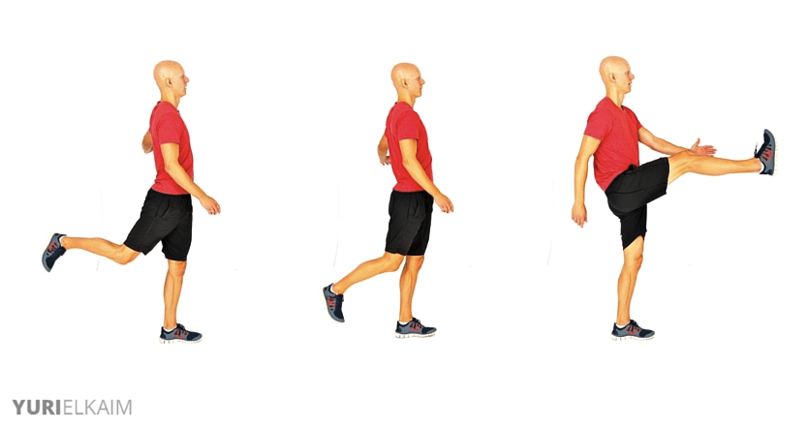

- **Walking Lunges**: 2 sets of 10 reps per leg

- **Bodyweight Squats**: 2 sets of 15 reps

### Workout

**1. Barbell Back Squats**

- Focus: Strength and power

- Sets: 5

- Reps: 6-8

- Rest: 2-3 minutes

- Load: Heavy (aim for 80-85% of your 1RM)

**2. Romanian Deadlifts (RDL)** 

- Focus: Hamstring and glute strength

- Sets: 4

- Reps: 8-10

- Rest: 2 minutes

- Load: Moderate to heavy

**3. Bulgarian Split Squats**

- Focus: Unilateral strength and balance

- Sets: 4

- Reps: 8-10 per leg

- Rest: 90 seconds

- Load: Moderate

**4. Box Jumps**

- Focus: Explosive power

- Sets: 3

- Reps: 10-12

- Rest: 90 seconds

- Note: Use a box height that challenges you without compromising safety.

**5. Hip Thrusts**

- Focus: Glute strength

- Sets: 3

- Reps: 10-12

- Rest: 90 seconds

- Load: Moderate to heavy

**6. Walking Lunges with Dumbbells**

- Focus: Strength and endurance

- Sets: 3

- Reps: 12-15 per leg

- Rest: 60-90 seconds

- Load: Moderate

**7. Calf Raises**

- Focus: Calf strength and endurance

- Sets: 3

- Reps: 12-15

- Rest: 60 seconds

- Load: Moderate

**8. Plank Variations (e.g., Side Planks, Plank to Push-Up)** 

- Focus: Core stability

- Sets: 3

- Reps: 30-45 seconds per variation

- Rest: 60 seconds

**Endurance and Speed Training (30 minutes):**

- HIIT (High-Intensity Interval Training) on Treadmill:

- 5-minute warm-up at a moderate pace

- 30 seconds sprinting at maximum effort

- 60 seconds walking or light jogging (active recovery)

- Repeat the sprint/walk cycle for 10-15 minutes

- Uphill Running: 3 sets x 2-minute sprints at a challenging incline, followed by 1 minute of rest between sets

- Plyometric Exercises:

- Box Jumps: 3 sets x 10 reps

- Jump Squats: 3 sets x 12 reps

- Burpees: 3 sets x 10 reps

### Cool Down and Stretching

Finish with a cooldown to help reduce muscle soreness and improve flexibility. This should take about 10-15 minutes.

- **Static Stretching**: Focus on quads, hamstrings, glutes, calves, and hip flexors.

- **Foam Rolling**: Target major muscle groups for recovery.

**Saturday:**

shoulders

### Warm-Up

Start with a dynamic warm-up to activate the shoulder muscles and prepare for the workout. This should take 10-15 minutes.

- **Arm Circles**: 2 sets of 30 seconds (forward and backward) 

- **Shoulder Dislocations**: 2 sets of 10 reps

- **Shoulder Shrugs**: 2 sets of 10 reps

- \*\***Band Pull-Aparts**:** 2 sets of 15 reps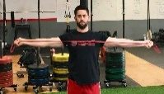

### Workout

**1. Barbell Overhead Press (Military Press)** 

- Focus: Strength and muscle mass (anterior deltoids)

- Sets: 4

- Reps: 6-8

- Rest: 2-3 minutes

- Load: Heavy (aim for 80-85% of your 1RM)

**2. Dumbbell Lateral Raises**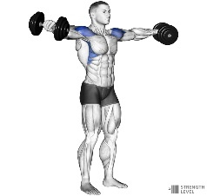

- Focus: Building a round shape (medial deltoids)

- Sets: 4

- Reps: 10-12

- Rest: 90 seconds

- Load: Moderate

**3. Seated Arnold Press**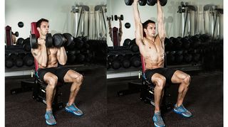

- Focus: Strength and shoulder stability (anterior and medial deltoids)

- Sets: 3

- Reps: 8-10

- Rest: 2 minutes

- Load: Moderate to heavy

**4. Dumbbell Front Raises**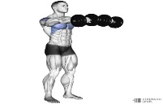

- Focus: Endurance and anterior deltoids

- Sets: 3

- Reps: 10-12

- Rest: 90 seconds

- Load: Moderate

**5. Face Pulls**

- Focus: Upper back and rear deltoids

- Sets: 3

- Reps: 12-15

- Rest: 60-90 seconds

- Load: Moderate

**6. Dumbbell Rear Delt Flyes**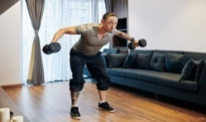

- Focus: Isolation of rear deltoids

- Sets: 3

- Reps: 10-12

- Rest: 90 seconds

- Load: Moderate

**7. Explosive Push-Ups (Clap Push-Ups)** 

- Focus: Explosiveness and shoulder engagement

- Sets: 3

- Reps: 8-10

- Rest: 90 seconds

**8. Barbell Shrugs**

- Focus: Trapezius development

- Sets: 3

- Reps: 10-12

- Rest: 90 seconds

- Load: Moderate to heavy

‘**8. Upright Rows**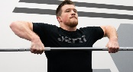

* Focus: Upper traps and shoulders
* Sets: 3
* Reps: 8-10
* Rest: 90 seconds
* Load: Moderate to heavy
* Note: Use a barbell or dumbbells; maintain proper form to avoid shoulder strain.

### Cool Down and Stretching

Finish with a cooldown to aid recovery and flexibility. This should take about 10-15 minutes.

- **Static Stretching**: Focus on shoulders, neck, and upper back.

- **Foam Rolling**: Target the upper body for recovery.